**Premier Athletics 2023** 

**Premier Athletics Winter Classes ages 3 & up**

* Feb-March (8 weeks)
* $45/$50 per month
* Beginner Cheer level 1, Cheer level 2,

**Premier Athletics Summer Camp open to anyone ages 3 & up**

**Do not need to be registered for Sideline Recreational Cheer to participate!**

* Held at Homefield Olathe
* Camp #1 June 28-30th 5-7pm camp/ Perform at game Saturday July 1st
* $80 for each camp, $10 discount for siblings. Includes t-shirt **does not include Monarch game tickets. These available at a discounted rate**

**Premier Athletics Recreational Sideline Cheerleading**

* No tryouts. Open to grades K-6th
* Registration May 1-July 1

**Time Commitment**

* Practices- begin August 7th. Mandatory practice starts when school begins.
* K-3rd grade practice 1 hour once a week Time and Date TBD
* 4th-6th grade practice 1.5 hours once a week Time and Date TBD

**Games/Performances**

* Games start weekend after Labor Day
* 5-7 football games per season
* 1 JCCC halftime Performance
* 1 Cheer Competition/Exhibition
* End of season showcase.
* Old Settlers Parade

**Costs**

* Registration Fee $125.00- includes bow and practice tank/tee, liability insurance, and music admin fee.
* Facility fee - K-3rd = $110, 4th and up = $120 (2022 prices)

**Uniform**

* K/1st & 3rd-6th grade new uniform or just shell this year (shell- $50.00 and skirt $25 or $35) See pictures below of uniform.

**Teams**

* Cheer teams will be created by grade. ** Grades K-3rd will not exceed 12-14 athletes per team**
* Each team will have at least 2 volunteer Coaches.

**Summer Camp**

* Mandatory Rec team camp held at Olathe West High School with OW cheerleaders. K-3rd grade 9am-noon $15, 4th-6th grade 9am- 4pm $30.

**Premier Athletics Recreational Performance Competition Teams**

* Costs - $700 - $1000.00 depending on how many competitions. This price includes facility rental at The Cheer Pitt Gym, Uniform & bow, Competition Fee, Music, Choreography, Insurance
* If you are a returner and your uniform fits your cost = $550-$850
* Tryouts - Beginning of Sept open to grades 4th and up.
* Choreography Camp - Mid Sept
* Time commitment- 4-5 months. Practice starts at the end of Sept and is held at TCP Sundays 4:30-6pm. The last competition will be in January or February.
* Competition – 4-6 local cheer competitions

**Recreational Team Uniforms:**

K-3rd grade - Royal blue, white, silver



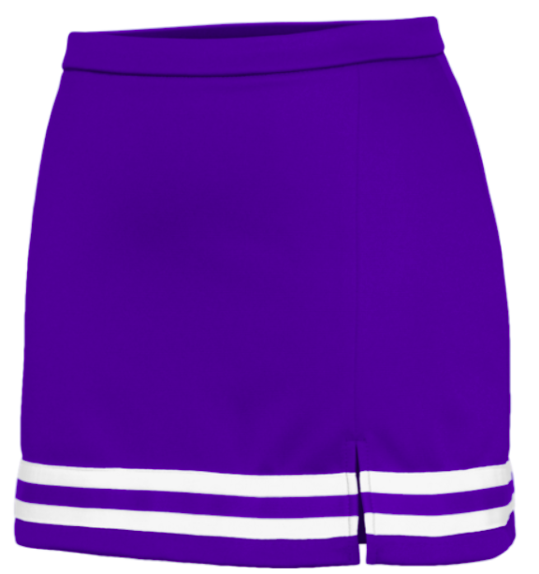

**4th - 6th grade - Royal blue, white, silver**

**Premier All-Stars Uniform - Black, silver, royal blue**